EB 251
1000 Chastain Road,
Kennesaw, GA 30144

April 20, 2011

Brandi Cooke and KABinet
Kennesaw State University
1000 Chastain Road, MD 0501
Kennesaw, GA 30144

Re: Outdoor movie project proposal

Dear Ms. Cooke:
We are submitting herewith our proposal for a recurring outdoor movie night to encourage and increase student involvement in campus life.
The purpose of this proposal is convince the Kennesaw Activities Board (KAB) that an outdoor movie event would be successful for the Kennesaw State University (KSU) student body and campus life, and that our group is the best candidate to research and plan the event.
The proposal covers detail the proposed program, plan of action, budget, the team’s qualifications, and schedule for completing a successful project.
We earnestly hope that this report will meet your approval. If you have any questions or comments regarding the interpretation of this report, please contact us via telephone at 678-797-2552. Thank you for your consideration of this project, and we look forward to hearing from you.
Respectfully yours,

Stephen Morrissey, Johnny Marr, Andy Rourke, Mike Joyce
/spm
Enclosure: Proposal

Recurring Outdoor Movie Night at KSU



To: Brandi Cooke, KAB President

and KABinet

By Stephen Morrissey, Johnny Marr,
Andy Rourke, and Mike Joyce

Prepared April 20, 2011

Executive Summary
We have created a strategic plan to generate a recurring outdoor movie night at Kennesaw State University (KSU).
To reach this goal, we plan to conduct research and provide recommendations for a successful outdoor movie night on KSU campus. Research will be steered towards student interest, location, equipment, dates and frequency, licensing of movies, and funding. Results of our research will be provided in a formal report, which we will deliver to you if you choose to hire our group.
Based on preliminary research, a recurring outdoor movie night has great potential to be a success among the KSU population, especially students living on campus. It is our job to create a plan from this proposal by taking advantage of the methods mentioned above, therefore increasing the number of students, faculty, and staff attending an outdoor movie as well as labeling this event a part of campus culture.
The duration of this proposal will be from April 20-25. We strive to provide a plan that will have the maximum benefit with minimal cost. While our report will contain more information, we estimate that the cost of an outdoor movie night will be $900 to $1400.
We are delighted at the opportunity that KAB has provided to us and believe that this campaign will be successful in accomplishing the goal of generating a recurring outdoor movie night at Kennesaw State University.

Table of Contents
Introduction 1
Statement of Problem and Background 1
Scope and Forecast of Proposal 1
Project Summary 2
Proposed Program 2
Plan of Action 2
Student Interest 2
Date and Frequency 3
Location 3
AV Equipment 4
Movie and Licensing 4
Budget 4
Qualifications 4
Budget 5
Budget for Report 5
Budget Predictions for Outdoor Movie 5
Schedule 5
Conclusion 6
References 7

Introduction
The purpose of this proposal is to convince the Kennesaw Activities Board (KAB) that an outdoor movie event would be successful for the Kennesaw State University (KSU) student body, and that our group is the best candidate to research and plan the event.

Statement of Problem and Background
KSU Residence Life and KAB have both sponsored outdoor movies for KSU students in the past. These types of events benefit the university because they encourage students to become involved in campus life.
KAB has previously sponsored a movie event called Screen on the Green. According to Keon Ghaffar-Jabbari, CineKAB coordinator from 2008 to 2010, the Screen on the Green event during Spring 2010 was a success. Over 150 students attended, and those students gave positive feedback about it (Ghaffar-Jabbari). While these previous outdoor movies have been successful, there is no consistently recurring outdoor movie night.
By hosting an outdoor movie night on a consistent basis, such as once each semester, the event can become part of campus culture. Students will look forward to attending the event each semester.
This fits well with the goals of the university. According to KSU’s 2007 to 2012 Strategic Plan, KSU is striving to “increase percentage of students participating in Student Life activities by 5 percent per year” (Kennesaw State University Relations). KSU continues to transition from a commuter school to a more traditional university with on-campus housing. Therefore, we expect that Student Life involvement will continue to be part of KSU’s strategic planning for years to come.

Scope and Forecast of Proposal
The scope of this proposal is to propose a report, which will recommend our solution to increase student involvement in campus life and events at KSU. This project is intended to affect KSU students only.
We will first explain our proposed solution and plan of action. Then we will offer our qualifications, followed by a proposed budget and schedule for writing the report.

Project Summary

Proposed Program
Implementing an outdoor movie night will require a lot of planning, especially for the inaugural event. If you hire our group, we will research the feasibility and make recommendations on six key elements. With our recommendations, KAB could more easily implement the outdoor movie idea.
These are the six key elements we have identified:
- Student interest
- Date and frequency
- Location
- AV equipment, to include a projector, a screen, speakers, and power for all devices
- A movie, in compliance with legal licensing
- Budget
Other elements could improve the event and increase student interest, such as offering concessions.

Plan of Action
If we are hired, we will deliver a report to you, which will focus on addressing the six key elements described above. In this plan of action, we describe how we will research each element.

Student Interest
We will address student interest by researching similar events, including outdoor movies previously hosted at KSU and outdoor movies at other universities. We will perform this research by talking to former CineKAB coordinators about KSU events, and by researching other universities online.
We will also develop and distribute a short survey to students in order to assess current interest in this type of event.
Finally, we will develop a basic plan for advertising the event to students.

Date and Frequency
We will need to determine how often the event should occur, such as annually or semesterly. We will research and propose specific dates for the event.

Location
Possible locations on KSU campus are the campus green (see Figure 1) or the Legacy Gazebo and amphitheater (see Figure 2). Our report will include a recommendation of the best location on campus.
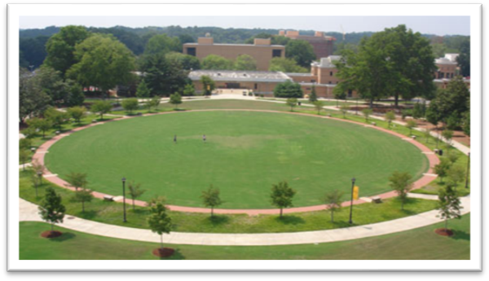
Figure 1: Campus green
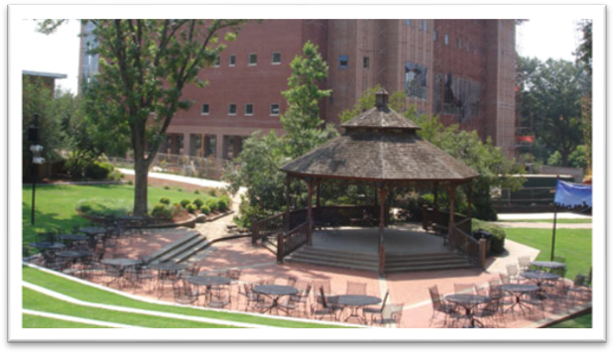
Figure 2: Legacy gazebo
Photos courtesy of Kennesaw State University
http://www.kennesaw.edu/admissions/campus_tour

AV Equipment
We will work with KSU’s Audio Visual Technical Services group (AVTS) to obtain the necessary equipment, including a projector, a large screen, and speakers. AVTS will also need to be contracted to support the event and set up the equipment for each proposed date. According to Jeremy Walts of ATVS, they already own all the necessary equipment. If we are able to coordinate with AVTS for our desired dates, this will be a large cost savings.

Movie and Licensing
First, we will need to research what type of movie to show. Options include a current film, or an older film like a 1980s classic. Older movies may have the benefit of cost savings over newer titles, but our research will also need to include what students will want to see. Therefore, we will include this topic in our short survey to students.
After deciding what kind of movie we want to show, we’ll need to determine where to acquire the movie and license. Licensing will be an important part of our plan, since a legal violation could have dire consequences for KSU.

Budget
Finally, we will develop a detailed budget based on all the above determinations.

Qualifications
First and foremost, we are all students at Kennesaw State University. Our majors range from marketing to biology. We understand the need for a reoccurring outdoor movie night at KSU. As students, we agree with KSU’s strategic plan to increase student participation.
One of our group members does market research at the Brixton Academy in London, England. She writes and edits promotional material for print and social media, conducts research, assists with media outreach and maintaining media list, and plans events. These qualifications give our group a great perspective on both advertising the event and the logistics of the event.
Another group member, Mike Joyce, is your fellow KAB coordinator and KABinet member. He manages and operates Flix4(ks)U, an iPhone video provider on campus for students, faculty and staff. He offers an inside perspective on student life and KAB.

Budget

Budget for Report
The time that we will spend researching and writing this report will be free. We will not ask for a monetary fee, but instead ask for community service hours through Volunteer KSU. We would also accept donations in the form of gift cards to places like Wal-Mart, Kroger, Target, or Quik-Trip.

Budget Predictions for Outdoor Movie
The estimated budget for each event is between $900 to $1400. The license for a movie will run between $300 to $600, depending on the movie chosen. Additional funds will be needed for advertising and possibly concessions. By coordinating with KSU’s AVTS department for the audio-visual equipment, we can save $600 to $800 that would have been spent on equipment rental.

Schedule
To realize this project, a thought-out schedule must be established. The first thing that we will do is to conduct research. Research would take two working days, a total of 20 hours, with one person working on it. After the research is done, all the data would be collected and analyzed, and the best possible solution would be selected. This would take one day. After we have selected the solution, we will determine how and when would be the best to implement the plan and write up a report. Writing and editing the report would take two more days.
If you hire us to research feasibility and write this report, we could begin working right away. Table 1 is a Gantt chart depicting our schedule if we are able to begin working immediately.
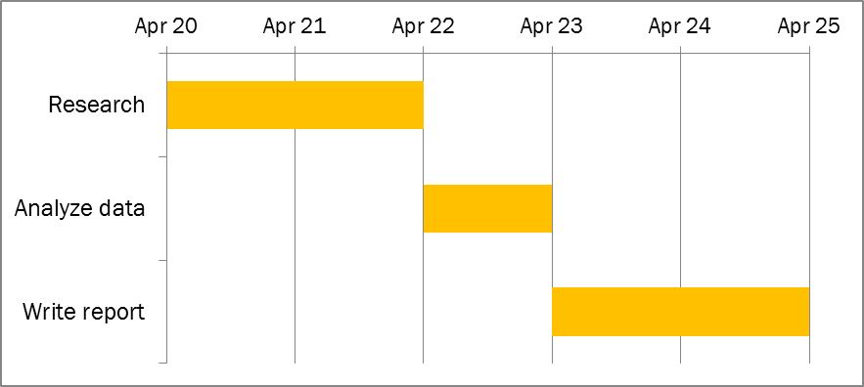
Table 1: Schedule of ____________ beginning April 20

Conclusion
In conclusion, we hope that we have convinced you that an outdoor movie event would be successful for the KSU student body and that our group is the best candidate to research and plan the event.
By establishing a recurring outdoor movie night, we believe that we will meet a number of needs for KSU. According to KSU Strategic Plan 2007-2012, KSU plans to increase the percentage of students participating in Student Life activities by 5% per year. By launching this plan, an outdoor movie night on a consistent basis will promote school spirit within the KSU community and become part of the KSU tradition.
Our group is the best candidate to generate this plan because of our qualifications. We are part of the KSU community in the fact that we are all students. As students of the university, we understand the need to generate interest in school activities. We also have a range of criteria that are well suited to researching, developing, and acting out this plan.
With strategic methods set in place, the duration of this proposal will have the maximum benefit with minimal cost of $1000.
We look forward to establishing a recurring outdoor movie night for the KSU community and the opportunity that KAB can provide to us.

References
Ghaffar-Jabbari, Keon. Former CineKAB coordinator Wilmonia Harris. 13 April 2011.
Kennesaw State University Relations. Kennesaw State University 2007-2012 Strategic Plan. 28 March 2007. 19 April 2011 <http://www.kennesaw.edu/president/strategic_plan07.pdf>.

Dr. Arnett’s Comments
Very nicely done! The proposal includes all the necessary parts, contains well-written and logically organized sections, and seems quite persuasive. It contains a handful of minor errors, but overall, I’m quite impressed with the quality of your group’s work.

